Chapter 4
Methodology
4.1 Introduction
This chapter explains how the cyberbullying detection system is built using deep learning and NLP. To build this cyberbullying detection system, we first collect text data from social media platforms such as Twitter. The collected texts are then cleaned and processed to make them ready for analysis, including steps like breaking them into words, removing unnecessary parts and standardizing the words. Then two advanced pretrained models, BERT and RoBERTa are fine-tuned on the tweets to learn what they mean and the context.
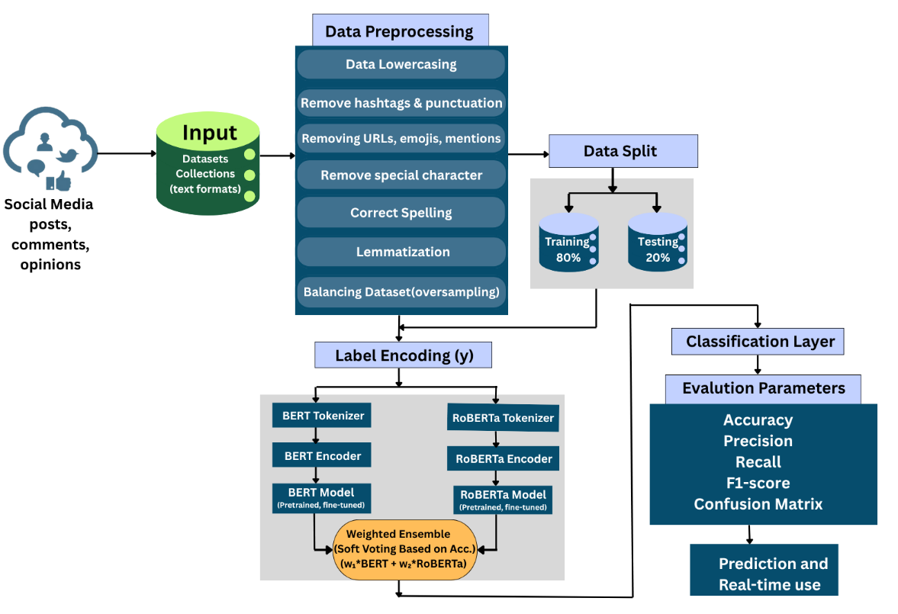
Figure 4.1: Overview of the proposed transformer-based cyberbullying detection framework.

4.2 Dataset
For this project, we collect a dataset of tweet text data from publicly available on social media sources for detect cyberbullying. The tweets were gathered using keyword-based filtering and included both bullying and non-bullying content to ensure a balanced dataset for cyberbullying detection. Then we organized, cleaned and prepared the collected tweets for use in the detection system. Since, the performance of any machine learning model depends heavily on data quality, careful dataset selection and cleaning were essential steps in developing the proposed cyberbullying detection system.
4.2.1 Data Source
We constructed our comprehensive dataset by combining two main sources:(i) Primary Source (ii) Secondary Source
For the first and primary source, we actively tracked real-time tweets for two days running a custom Python script on Heroku that connected to the Twitter API. We focused on gathering raw authentic language by targeting specific keywords related to racial, gender, and religious biases (like dyke, bitch, jihad, and ban Islam). This strategy ensured our initial corpus accurately reflected the volatile and nuanced expressions of online bias in real-time social media.
The secondary source, the “Cyberbullying Tweets Dataset” from Kaggle was leveraged to enhance our data. This precompiled dataset provided in CSV format offered pre-categorized labels for cyberbullying, non-cyberbullying and specific subtypes (e.g., age, religion, ethnicity). Its inclusion provided fine-grained labeling and balanced class representation, mitigating training imbalance. The combined dataset was then systematically preprocessed.
4.2.2 Dataset Size and Format
The final dataset analyzed for model training and evaluation comprised approximately 47,000 tweets. The data, primarily sourced from Twitter, was maintained in a CSV format. It included two key attributes: the text of the message, labeled as tweet_text, and its corresponding category labeled as cyberbullying_type and classified into Cyberbullying or Non-Cyberbullying. Fine-grained subtypes (religion, age, ethnicity, gender) were also available that helping us ensure a balanced representation of classes.
4.2.3 Dataset Description
Our final working dataset is essentially a huge collection of online conversations, consisting of 47,656 English text posts. Sourced from platforms like Twitter and Facebook, each post averages about 24 words. We didn't just label things as “Bullying” or “Not Bullying” but used six distinct categories including specific targets like Religion, Age, Ethnicity and Gender. This detailed breakdown makes our data highly suitable for comprehensive analysis and training a model to spot many different kinds of harm.

Info. | Details
Total Data | 47,656
Classes | Religion, Age, Ethnicity, Gender, Not Cyberbullying, Other Cyberbullying
Source | Social media platforms (Twitter, Facebook)
Data Type | Text (English)
Average Text Length | 136 characters / 23.7 words
Remarks | Multiple cyberbullying categories; Suitable for analysis and modeling.
Table 4.1 key features of the dataset are summarized below

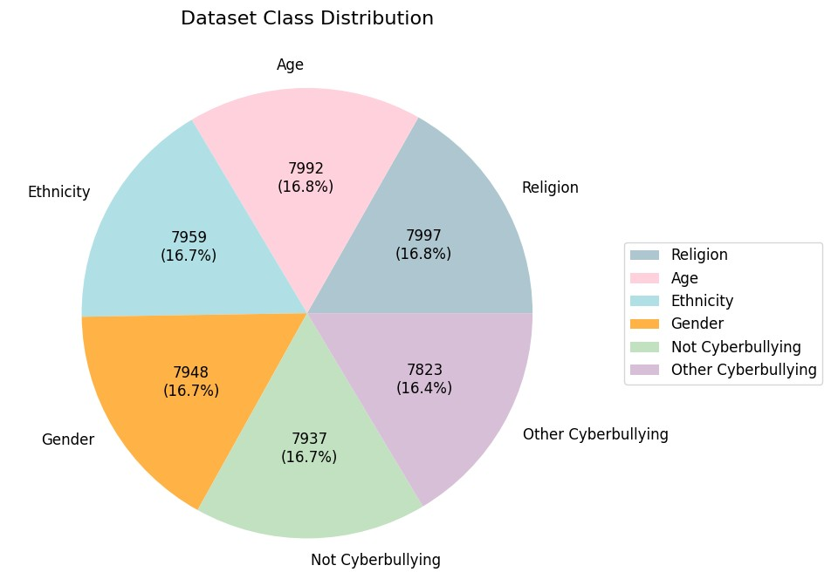
Figure 4.2: Distribution of Tweets in the Dataset Classes

Figure 4.2: This pie chart shows the distribution of tweets across six classes in the dataset. The total dataset contains 47,656 tweets. The class-wise distribution is: Religion (7,997), Age (7,992), Ethnicity (7,959), Gender (7,948), Not Cyberbullying (7,937), and Other Cyberbullying (7,823). Each class holds roughly 16–17% of the data, indicating a well-balanced dataset suitable for reliable model training.
4.3 Data Preprocessing
Preprocessing plays a critical role in preparing social media text for machine learning and deep learning models. Tweets, particularly those related to cyberbullying, often contain noisy, unstructured, and domain-specific language, including URLs, hashtags, mentions, emojis, slang, spelling errors, repeated characters, and informal abbreviations. Systematic preprocessing ensures that textual data is clean, consistent, and suitable for deep learning models. Thereby improving the detection of cyberbullying and sentiment patterns, the preprocessing steps applied in this study are detailed below.

4.3.1 Text Cleaning and Normalization

After collecting the data, our first task was to clean the texts and make them noise-free. To ensure text uniformity and meaningful representation, several preprocessing techniques were applied to the raw tweets before feeding them into the model. These steps aimed to remove noise, standardize linguistic patterns, and improve feature quality for model training and embedding generation. Table 4.2 summarizes the preprocessing steps that applied in this study.

Table 4.2: Text Cleaning steps and Examples
Step | Before | After
Lowercasing | “Stop Cyberbullying NOW!” | “stop cyberbullying now!”
HTML Tag Removal | “Check this out <a href='link'>here</a>” | “Check this out here”
URL Removal | “Visit http://facebook.com now!” | “Visit now!”
Hashtags and Mentions | “#StopCyberBullying @user” | “Stop Cyber Bullying”
Punctuation & Repeated Characters | “Nooo!!! Why???” | “no why”
Emoji Handling | “I’m so happy 😄” | “I’m so happy”
Chat Words and Short Forms | “idk why u bully” | “I do not know why you bully”
Spelling Correction | “cybrbullyng is bad” | “cyberbullying is bad”
Contraction Expansion | “don’t be rude” | “do not be rude”
Remove Stopword | “I do not like bullying” | “like bullying”
Non-English/Non-ASCII Filtering | ¿Por qué bullying?” | removed
Remove Numbers & Short Words | “I’m 15 and bullied” | “bullied”
Tokenization | “I hate online trolls!” | [“I”, “hate”, “online”, “trolls”, “!”]
Lemmatization | “She is running faster than her friends.” | “She be run faster than her friend.”
Extra Space Cleaning | “ Say no to cyberbullying! ” | “Say no to cyberbullying!”
4.3.2 Handling Duplicate Tweets
To ensure data integrity and prevent the model from being biased by redundant information, duplicate tweets were systematically removed in two distinct stages. Duplicate entries primarily arose from retweets or repeated posts by users. We tackled this problem in two practical steps:
First Check (Raw Data): Before we started cleaning the text, we found a few initial copies, specifically 36 duplicate tweets. We got rid of these right away to start with a clean slate.
Second Check (Final Polish): After all the cleaning steps were done, we checked again. Sometimes the cleaning process can accidentally create new identical entries. This final check caught a bigger batch: 8,396 remaining duplicates. We removed all of these, too.
This rigorous, two-stage process guaranteed that every sample used for training and evaluation was unique, thereby enhancing the model's generalization capability.
4.3.3 Class Balancing
During our work, we observed that the dataset exhibited class imbalance, with some categories having fewer samples than others. To address this and prevent model bias we applied oversampling to the minority classes in the training set so that all classes had an equal number of samples as the majority class. In our dataset the age category was the majority class and the other classes ethnicity, gender and not_cyberbullying.

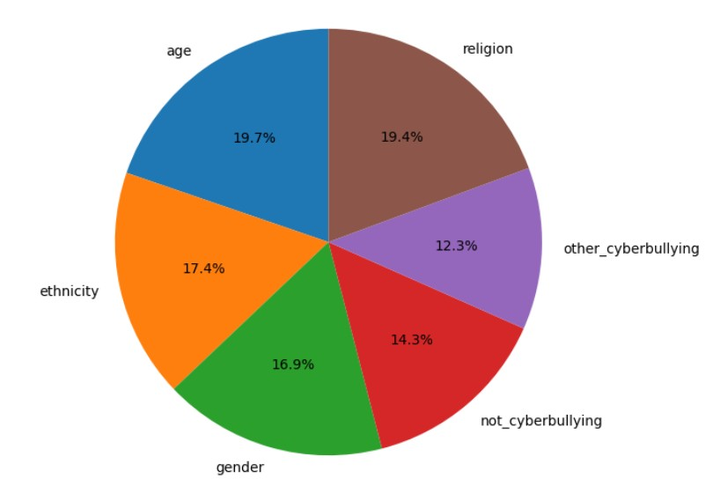
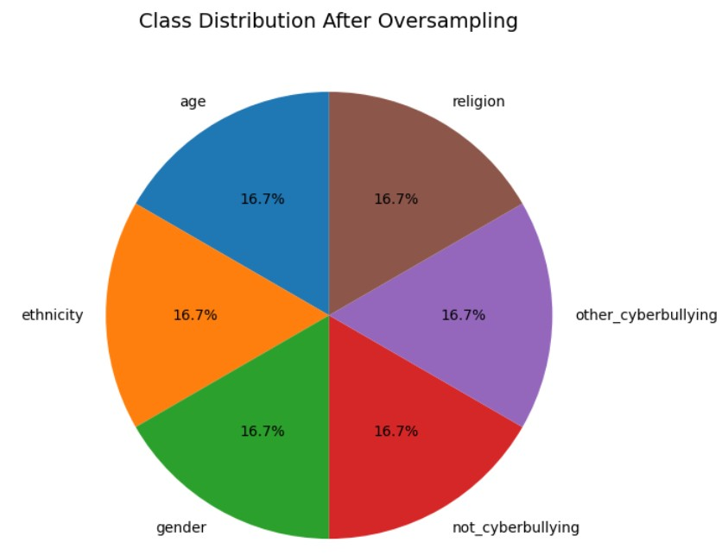
Before Oversampling
After Oversampling
Figure 4.3: Class Distribution Before and After Balancing

Here, age was the majority class while other classes such as ethnicity, gender, not_cyberbullying, and religion had fewer samples. In Figure 4.3 compares the original imbalanced class distribution with the balanced distribution obtained through Random Oversampling, where all minority classes were resampled to match the majority class size (6221 samples). After oversampling, the dataset became fully balanced Which shown in figure 4.3.
The balanced dataset was then shuffled and separated into features (X_train_balanced) and labels (y_train_balanced). This balancing process ensured equal representation of all classes during training, enabling the model to generalize better and accurately detect different types of cyberbullying.
4.4 Model Architecture
This section outlines the design of the proposed deep learning framework developed for cyberbullying detection and sentiment classification. The proposed system leverages transformer-based language models, specifically and RoBERTa to extract deep contextual and semantic information from textual data. These models are well-suited for understanding the nuanced and informal nature of social media language, enabling precise identification of cyberbullying patterns across various categories such as age, gender, ethnicity, religion, and non-cyberbullying content.
The overall architecture is divided into three main components:(i) The base transformer models, (ii)The fine-tuning strategy and (iii)Ensemble for Robustness to integrate knowledge from multiple models. Both BERT and RoBERTa are pre-trained on massive text corpora and are subsequently fine-tuned on the cyberbullying dataset to adapt their learned linguistic representations to the target task.
4.4.1 Base Models (BERT and RoBERTa)

BERT (Bidirectional Encoder Representations from Transformers) is a deep bidirectional model developed by Google, designed to understand the context of words in both left and right directions within a sentence. It consists of multiple self-attention and feed-forward layers that encode linguistic relationships at different abstraction levels. In our project, we used the “bert-base-uncased” variant which includes 12 encoder layers, 12 attention heads and a hidden size of 768.
BERT is the foundational encoder which processing input text bidirectionally to generate deep contextualized word embeddings. Trained using Masked Language Modeling (MLM) and Next Sentence Prediction (NSP) on a large corpus, it captures complex semantic relationships and dependencies within the social media text. The model's output provides the primary classification representation (the final hidden state of the [CLS] token) for the subsequent fine-tuning stage.
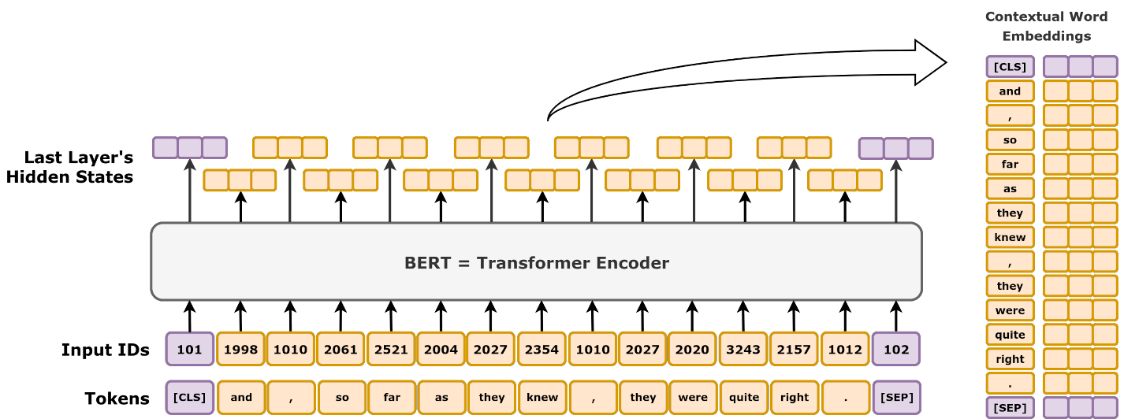
Figure 4.4: High-level schematic diagram of BERT.
It takes in a text, tokenizes it into a sequence of tokens, add in optional special tokens and apply a Transformer encoder. The hidden states of the last layer can then be used as contextual word embeddings.
RoBERTa (Robustly Optimized BERT Pretraining Approach) is an optimized variant of BERT, featuring a more rigorous training regimen that includes a significantly larger corpus, larger batch sizes, and the removal of the NSP task. It utilizes dynamic masking, which enhances its generalization capability. Including RoBERTa ensures the ensemble benefits from a more robust and refined set of linguistic features, offering a complementary perspective to BERT for improved overall detection accuracy.
During fine-tuning, the pre-trained RoBERTa model was extended with a task-specific classification head followed by a Softmax activation layer to classify input text into cyberbullying and non-cyberbullying categories. The model was fine-tuned on our labeled dataset to adapt to domain-specific linguistic patterns, enhancing its ability to detect subtle and implicit forms of online harassment.
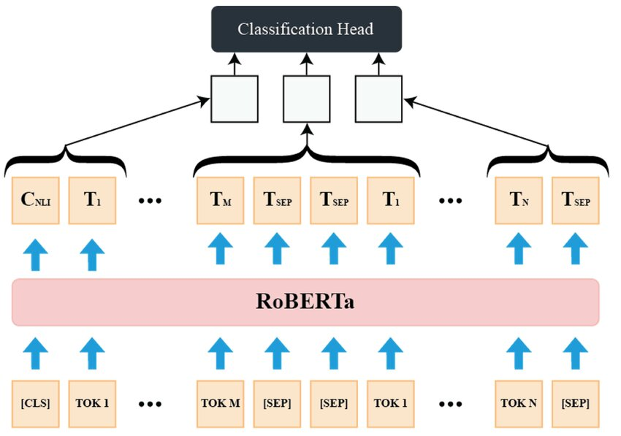
Figure 4.5: Architecture of RoBERTa
The Figure 4.5 depicts the structure for fine-tuning a RoBERTa model for a multi-text classification task. Text input is first converted into a sequence of tokens (e.g., [CLS], TOK 1, [SEP]). The model takes tokenized input, uses the RoBERTa encoder to create contextual representations, and then passes the relevant classification token vectors (like $C_{NLI}$ or [CLS]) to a Classification Head to produce the final predictions for the downstream task, such as cyberbullying detection.
4.4.2 Fine Tuning Strategy
The fine-tuning phase is a crucial step that bridges the gap between the general linguistic knowledge encoded in the pre-trained transformer models and the specific demands of the target task: multi-class cyberbullying detection and sentiment classification. This strategy involves modifying the model's output layer and optimizing the entire architecture using the labeled dataset.
Structure: This head typically consists of one or more dense (fully connected) layers followed by an activation function (like ReLU) and a final output layer.
Input: The input to the Classification Head is the hidden state vector of the designated classification token (e.g., the [CLS] token's final hidden state in BERT/RoBERTa) from the last transformer layer. This vector encapsulates the overall sentence representation.
Output: The final dense layer produces logits corresponding to the classification task categories (e.g., age-based bullying, gender-based bullying, non-bullying etc.). For a multi-class task, the Softmax activation function is applied to these logits to yield the final probability distribution.
Loss Function: The training objective is typically defined by the Cross-Entropy Loss function$(L_{CE})$. This function measures the difference between the model’s predicted probability distribution and the true label distribution.
$$L_{CE}=-\sum_{c=1}^{C}{y_{c}log⁡(\hat{y_{c}})}$$
where $C$ is the number of classes, $y_{c}$is the true binary indicator (1 or 0) for class $c$, and $\hat{y_{c}}$is the predicted probability for class $c$.
Optimization Algorithm: The AdamW optimizer is utilized which is preferred for its effective handling of weight decay and its robust performance when fine-tuning transformer models.
Learning Rate Policy: A low and carefully selected learning rate (typically 1e-5 to 5e-5) is employed. This low rate is crucial for preventing catastrophic forgetting, ensuring that the extensive linguistic knowledge acquired during pre-training is gently adjusted rather than overwritten by the new, task-specific data.
Training Schedule: The training process is typically short (e.g., 2 to 4 epochs) due to the models' high capacity and fast convergence rate on downstream tasks. Early stopping is employed based on validation set performance to prevent overfitting.

Table 4.3: Overview of the Fine-Tuning Strategy
Aspect | Component | Description
Objective | Bridge the gap between pre-trained knowledge and multi-class cyberbullying detection. | Modifies the entire architecture using the labeled dataset.
Structure | Classification Head (Dense layers + Activation) | Head typically consists of one or more dense (fully connected) layers followed by an activation function (like ReLU) and a final output layer.
Input | Hidden state vector of [CLS] token from the last transformer layer. | This vector encapsulates the overall sentence representation.
Output | Softmax activation on logits. | Produces the final probability distribution over classification categories (e.g., age-based, gender-based bullying, non-bullying).
Loss Function | Cross-Entropy:  $${(L}_{CE}=-\sum_{c=1}^{C}{y_{c}log⁡(\hat{y_{c}})}$$ | Measures the difference between the model's predicted probability $⁡(\hat{y_{c}})$ and the true label ($y_{c}$)
Optimization | AdamW optimizer | Preferred for its effective handling of weight decay and robust performance when fine-tuning transformer models.
Learning Rate | Low (typically 1e-5 to 5e-5) | Crucial for preventing catastrophic forgetting that ensuring gentle adjustment of pre-trained linguistic knowledge.
Training Schedule | Short (e.g., 2 to 4 epochs) | Due to high model capacity and fast convergence rate on downstream tasks.
Regularization | Early Stopping | Employed based on validation set performance to prevent overfitting.

4.4.3 BERT and RoBERTa Performance
Both fine-tuned models demonstrated strong performance in cyberbullying detection, effectively identifying offensive language across specific social attributes while minimizing false positives for neutral content. BERT provided a deeper understanding of contextual and sequential meaning while RoBERTa offered stable training and faster convergence due to its improved pretraining strategy.
To leverage their complementary strengths, the two models were integrated into an ensemble architecture. This combination enhances the overall decision-making process, especially for challenging categories such as gender-based or religion-related bullying. The main challenge was distinguishing borderline non-cyberbullying text, which required careful preprocessing and balanced training data.
4.5 Ensemble Method
The Ensemble Method serves as the final and critical stage of the architecture aiming to synthesize the complementary strengths of the fine-tuned BERT and RoBERTa models. As discussed in the individual performance analysis in (Section 4.4.3) combining models where one model performs better in terms of accuracy while the other is more consistent and stable during training. Combining them helps the system make more reliable predictions and reduces errors that might occur if only a single model were used.
4.5.1 Weighted Ensemble
In the weighted ensemble approach, the softmax probabilities from BERT and RoBERTa are combined based on predefined weights proportional to each model’s validation accuracy that reflect the relative reliability of each model. If $P_{BERT}$ and $P_{RoBERTa}$ denote the prediction probabilities of the two models, the final ensemble prediction probability for each class $C_{i}$ is calculated as:
$P$($C_{i}$)=$w_{BERT}×P_{BERT}(C_{i})+w_{RoBERTa}×P_{RoBERTa}(C_{i})$ (1)
The weights ($W_{k}$) for each model are determined based on their validation performance (Accuracy) and adjusted so that their total adds up to one, ensuring each model contributes proportionally:

$W_{k}=\frac{{Accuracy}_{k}}{\sum{{Accuracy}_{k}}}$ (2)
The class with the maximum ensemble probability is selected as the final prediction:
$$\hat{y}=\arg{\max{P(C_{i})}}$$
This method allows the ensemble to balance the strengths of the individual models, giving more influence to the model that is more reliable for a particular type of input and enhancing overall prediction robustness. This procedure ultimately enhances overall prediction robustness, utilizing BERT’s fine-grained contextual representation and RoBERTa’s enhanced sentence-level semantics proportionally to their observed efficacy.
4.5.2 Voting Ensemble
The voting ensemble determines the final prediction by combining the independent outputs of each base model. This approach first classifies the input text individually and then simple rules are applied to decide the final class. This strategy reduces random errors and increase decision reliability. Two strategies were tested:
Hard Voting (Majority Rule): In this approach each base model casts one vote for the class label it predicts (e.g., ‘Bullying’ or ‘Not Bullying’). The class that receives the majority of the votes is selected as the final ensemble prediction. This method is robust to noise and outliers. In Hard Voting equation each model gives one class label vote:
$\hat{y}=$ mode ($y_{BERT}$, $y_{RoBERTa}$​)
Soft Voting (Averaging Probabilities): This approach uses the Softmax probability outputs from both models. The class probabilities are combined either by taking a simple average or by using weighted averages (if the models have predefined weights as explained in Section 4.5.1). After averaging the class with the highest combined probability is selected as the final prediction. Soft Voting produces smoother and more stable probability scores and it often performs better than Hard Voting.
The class probabilities from each model are averaged:
$P$($C_{i}$) = $\frac{P_{BERT}\left(C_{i}\right)+P_{RoBERTa}(C_{i})}{2}$
The final predicted class is:
$$\hat{y}=\arg{\max{P(C_{i})}}$$

Table 4.6: Summary of Voting-Based Ensemble Techniques
Ensemble Type | Decision Rule | Output Used | Strengths
Hard Voting | Majority class label | Final Class Label ($\hat{y}$) | Robust to noise
Soft Voting | Mean of class probabilities | Class Probabilities ($P$($C_{i}$)) | Smooth probability distribution

4.5.3 Stacked Ensemble
The Stacked Ensemble or Stacking is a more advanced method for combining multiple models. It uses a two-level architecture that intelligently integrates the predictions of the base models and capturing complex dependencies that simpler voting methods may miss.
In this approach, BERT and RoBERTa serve as Level-1 learners generating Softmax probability distributions for each class on the validation set. These probability outputs are then used as input features for a Level-2 meta-classifier which in this study is implemented using a lightweight Logistic Regression model. Formally, the feature vector for the meta-classifier is represented as:
Z=$P_{BERT}\left(C_{1}\right),P_{BERT}\left(C_{2}\right),…,$ $P_{RoBERTa}(C_{1})$, $P_{RoBERTa}(C_{2})$

This approach provides a significant strategic advantage by enabling the fusion model to intelligently learn the conditions under which each base model is more reliable for specific categories. Empirical evaluation confirmed the efficacy of this method: the Stacked Ensemble strategy ultimately yielded the highest overall accuracy and F1-score across all cyberbullying types investigated.
4.6 Training Configuration
The performance of the multi-transformer architecture is highly dependent on a carefully optimized fine-tuning regimen. Table 4.7 details the specific hyperparameter settings employed to ensure stable convergence and maximum performance for both the BERT and RoBERTa base models.

Table 4.7: Training Configuration and Hyperparameter Settings
Parameter | Configuration | Description
Base Models | BERT (bert-base-uncased), RoBERTa (roberta-base)
  Pre-trained transformer encoders
Optimizer | AdamW | With decoupled weight decay for stability
Learning Rate | 2e-5 | Adaptive, with linear warm-up and decay
Loss Function | Cross-Entropy | For multi-class classification
Batch Size | 16 | Mini-batch training size
Epochs | 3 | Optimal after convergence on validation set
Dropout Rate | 0.3 | Applied before classification layer
Gradient Clipping | 1.0 | Prevents gradient explosion
Early Stopping | Enabled | Based on validation loss
Evaluation Metrics | Accuracy, Precision, Recall, F1-score | For quantitative performance evaluation
Table 4.7 summarizes the training configurations and hyperparameter settings. It provides details about the base models, optimizer, learning rate, loss function, batch size, number of epochs, dropout rate, gradient clipping, early stopping, and evaluation metrics used during training and validation.

4.7 Interface
The Cyberbullying Detection System can be designed with a simple, user-friendly and intuitive interface developed using Django. Users can register by providing Name, Username and Password or login with an existing account. The system allows text submission and the detection panel displays results clearly. If the input text or post contains harmful or offensive expressions the output shows “Bullying” if the statement is safe and non-harmful the system returns “Not Bullying”. This straightforward interface ensures that users can understand and interpret the model’s decision easily.
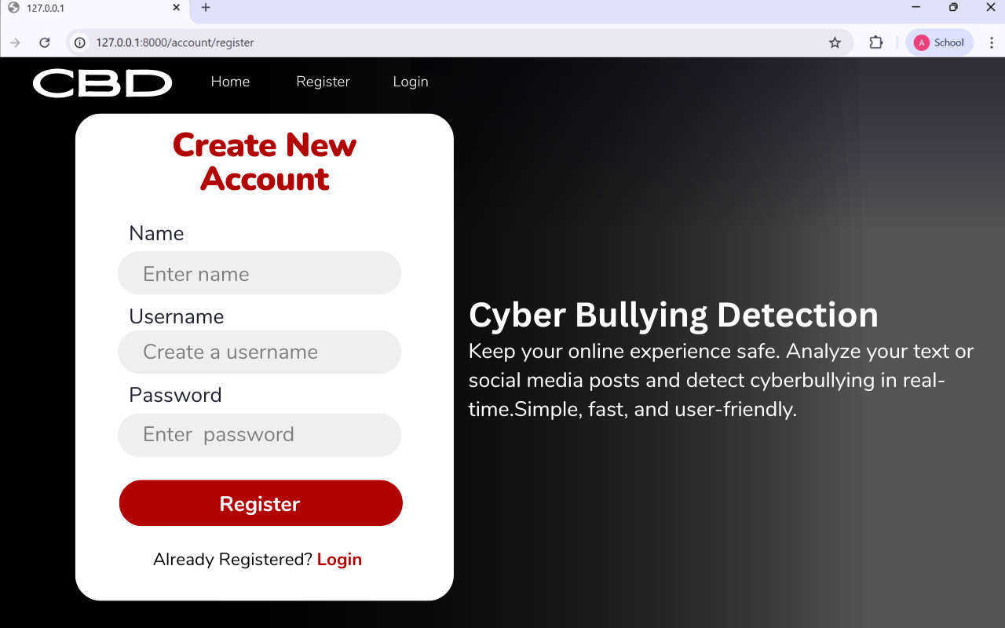
Figure 4.6: Account Registration page interface
4.7.1 Registration Page
The Registration Page is the initial secure gateway for new users to access the Cyber Bullying Detection (CBD) system. This interface (Figure 4.6) is where individuals without an existing account register by providing their Name, a unique Username and a secure Password to create new access credentials for the system. For registration page, the system uses Django to handle accounts, HTML and CSS for layout and design, JavaScript to make the page dynamic.

4.7.2 Login Page
If the user has an existing account, they can login with their already created credentials using the “Login” option provided on the navigation bar. Account Login page interface (Figure 4.7) which is the designated entry point for users who already possess an account. To gain access, users must input their registered Username and the corresponding Password into the dedicated fields. Like the Registration page, HTML and CSS define the structure and visual styling, while JavaScript contributes to the dynamic functionality. Upon successful verification, clicking the “Login” button initiates a redirection to the Analysis Dashboard. For user convenience, a "Register now" link is also available on this page for any user who may have mistakenly navigated here without having created an account.


Figure 4.7: Account Login page
4.7.3 Text Analysis and Results Page
The Text Analysis and Results Page serves as the main environment of the Cyber Bullying Detection (CBD) system and appearing automatically once the user logs into the platform. The Page is divided into two main panels, as shown in (Figure 4.8) Text Analysis and Detection Results page.
The “Analyze for Cyberbullying” panel is the input area, where the authenticated user can type or paste text (such as comments, posts, or messages) into the large text box. Clicking Analyze Text sends the input via an HTTP POST request to the Django backend API where it is preprocessed and analyzed by the BERT and RoBERTa ensemble model.

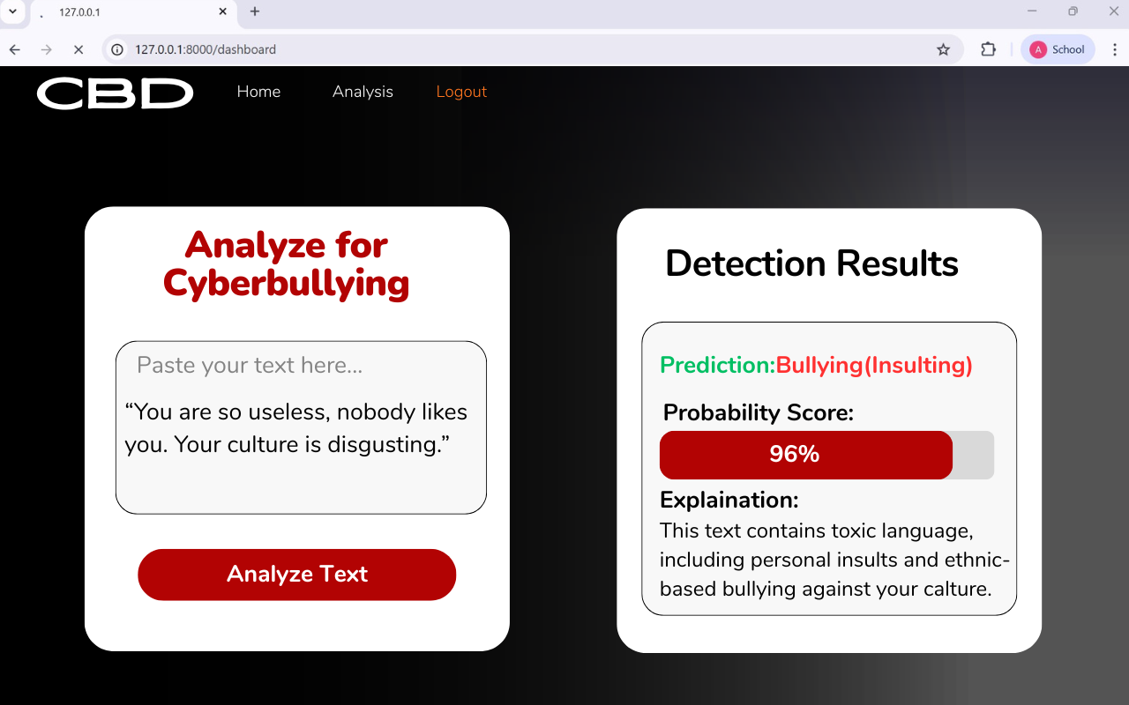
Figure 4.8: Text Analysis and Detection Results page

The results are sent back from the backend and displayed dynamically in the “Detection Results” panel (Figure 4.8) which providing immediate and detailed feedback to the user. The output includes the Prediction (e.g., Bullying (Insulting)). The Probability Score showing the model’s confidence (e.g., 96%) and an Explanation that highlights why the text was classified as bullying (e.g., “This text contains toxic language, including personal insults and ethnic-based bullying against your culture.”). This interactive design ensures a fast, transparent, and user-friendly detection experience.

Chapter 5
Results and Discussion

5.1 Introduction

This chapter presents and analyzes the experimental results of the proposed multi-transformer ensemble framework. Following the architectural design outlined in Chapter 4, the performance of the individual baseline models (BERT and RoBERTa) is evaluated and compared with multiple ensemble strategies (Weighted, Voting, and Stacked) on the test set. The findings directly address the core hypothesis of this thesis: that a learned fusion mechanism can outperform single-model approaches by providing improved accuracy, stability and generalization.

5.2 Evaluation Strategy
A rigorous evaluation strategy was adopted to ensure a robust and unbiased assessment of the proposed multi-transformer ensemble framework. All performance metrics were calculated on an independent, held-out test set, guaranteeing that the reported results accurately reflect the model’s generalization capability to unseen social media text.

5.2.1 Evaluation Metrics

To evaluate the proposed multi-transformer ensemble framework, we employed standard classification and efficiency metrics commonly used in text-based cyberbullying detection tasks. The metrics are defined as follows:

Accuracy (A): Measures the overall correctness of predictions. For example, if 950 out of 1,000 tweets are correctly classified as cyberbullying or non-cyberbullying, the accuracy is 95%.

Accuracy = $\frac{TP+TN}{TP+TN+FP+FN}$

Precision (P): The ratio of correctly predicted positive instances to all instances predicted as positive.

Precision = $\frac{TP}{TP+FP}$

Recall (R) / Sensitivity: The ratio of correctly predicted positive instances to all actual positive instances. If there are 200 actual bullying tweets and the model identifies 190, the recall is 95%.

Recall = $\frac{TP}{TP+FN}$

F1-Score (F): The harmonic mean of Precision and Recall, balancing both metrics.

F1= 2×$\frac{Precision×Recall}{Precision+Recall}$

Error Rate (E): The percentage of misclassified instances.

Error Rate = $\frac{FP+FN}{TP+TN+FP+FN}$
Inference Time (IT): The average time required by the model to make a prediction for a single instance.

IT =$\frac{T_{End}+T_{Start}}{N}$

5.3 Performance of the Proposed Method

The following Table 5.1 summarizes the overall performance of the individual base models (BERT and RoBERTa) and the final Ensemble model on the validation dataset. The results are presented across four standard classification metrics: Precision, Recall, F1-score and Accuracy.

Table 5.1: Performance Description of proposed models
Method | Precision | Recall | F1-score | Accuracy
BERT | 0.94 | 0.95 | 0.94 | 95.22%
RoBERTa | 0.94 | 0.95 | 0.94 | 95%
Ensemble | 0.95 | 0.95 | 0.95 | 96%

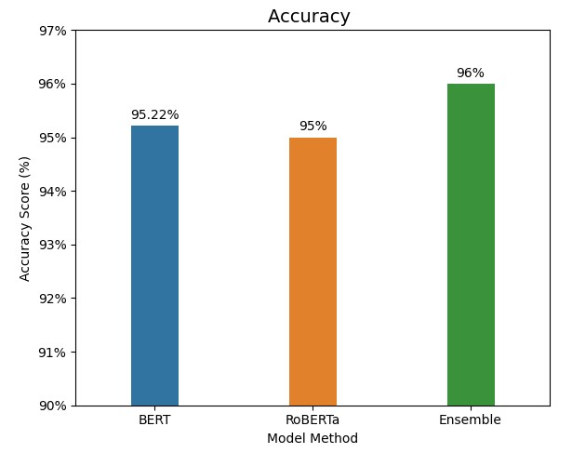
Figure 5.1: Accuracy score for BERT, RoBERTa and Ensemble Models

The figure 5.1 shows the overall performance of the three classification models using the Accuracy Score metric. The chart clearly shows that both the individual BERT and RoBERTa models achieved an accuracy of 0.95. The Ensemble model achieving the highest accuracy score of 0.96. The chart validates the methodological decision to use stacking as the ensemble technique yielded a noticeable improvement in overall prediction reliability.
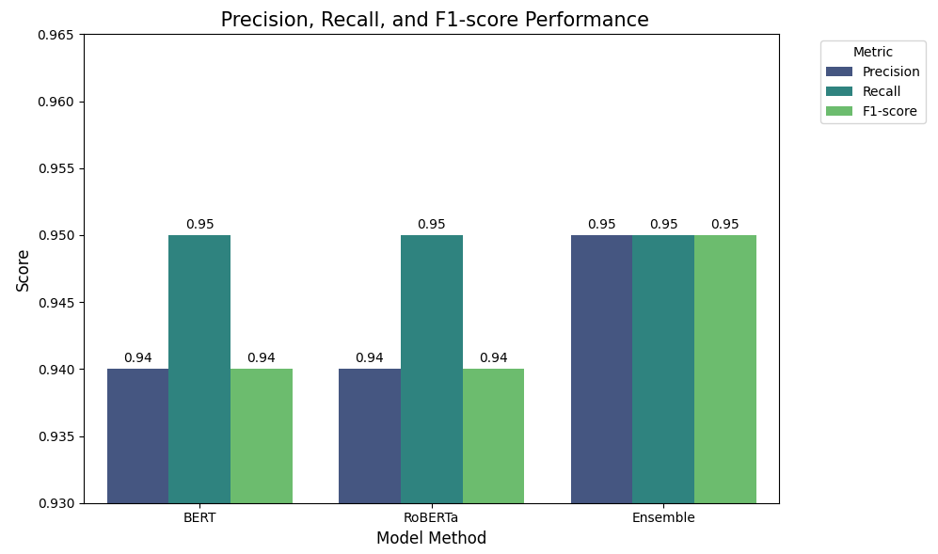
Figure 5.2: Precision, Recall and F1-score Performance of BERT, RoBERTa, and Ensemble Models

Figure 5.2 presents a comparative evaluation of the three model architectures BERT, RoBERTa and the proposed Ensemble method based on Precision, Recall and F1-score. Both BERT and RoBERTa exhibit strong and consistent performance achieving 0.94 Precision, 0.95 Recall and 0.94 F1-score. These results highlight their ability to accurately identify cyberbullying content across various categories while keeping false negatives low.
The Ensemble model which combines outputs from both BERT and RoBERTa, demonstrates a slight yet meaningful improvement achieving 0.95 across all three metrics. This indicates better class-level discrimination and improved handling of ambiguous or overlapping bullying cues. The consistent performance of the ensemble approach confirms that model fusion increases robustness and reduces individual model bias and delivers more reliable cyberbullying predictions across diverse text inputs.

5.4 Ablation Study

The ablation study examines how each part of the system contributes to the final performance. To assess their individual impact on system performance each component is selectively removed or isolated and the resulting changes in Precision, Recall, F1-score and Accuracy are evaluated. This helps us understand which parts are truly necessary and which parts make the model stronger and more reliable.
5.4.1 Performance of BERT Model
Performance Report for BERT: Table 5.2 shows the performance metrics of the BERT model for various classes, including precision, recall, F1-score, and support.

Category | Precision | Recall | F1-Score | Support
0 | 0.99 | 0.98 | 0.98 | 1555
1 | 0.99 | 0.99 | 0.99 | 1352
2 | 0.95 | 0.92 | 0.93 | 1333
3 | 0.86 | 0.88 | 0.87 | 1124
4 | 0.97 | 0.97 | 0.97 | 1522
Accuracy | -- | -- | 0.9522 | 6886
Macro avg | 0.95 | 0.95 | 0.95 | 6886
Weighted avg | 0.95 | 0.95 | 0.95 | 6886
Table 5.2: Classification Report of the BERT model

Accuracy: BERT achieved a test accuracy of 95.22%, indicating that the model correctly classified the majority of test samples across all five classes.
Precision: The model achieved high precision across all classes, ranging from 0.86 to 0.99, showing that most of the predicted class labels were correct.
Recall: Recall values ranged from 0.88 to 0.99, indicating that the model successfully identified most of the actual samples in each class. Class 3 had slightly lower recall (0.88), suggesting minor misclassification for this class.
F1-Score: The F1-scores ranged from 0.87 to 0.99, reflecting a balanced trade-off between precision and recall for all classes.
Support: The number of samples per class varied between 1124 and 1555, with a total of 6886 samples in the test dataset.

5.4.2 Performance of RoBERTa Model
Table 5.3 also shows the performance metrics of the RoBERTa model for various classes, including precision, recall, F1-score, and support.
Class Label | Precision | Recall | F1-Score | Support
0 | 0.99 | 0.98 | 0.98 | 1555
1 | 0.99 | 0.99 | 0.99 | 1352
2 | 0.95 | 0.91 | 0.93 | 1333
3 | 0.85 | 0.88 | 0.86 | 1124
4 | 0.96 | 0.97 | 0.97 | 1522
Accuracy | -- | -- | 0.95 | 6886
Macro Avg | 0.94 | 0.95 | 0.94 | 6886
Weighted Avg | 0.95 | 0.95 | 0.95 | 6886
Table 5.3 Classification Report of the RoBERTa model

Accuracy: RoBERTa achieved a test accuracy of 95%, demonstrating strong overall classification performance.
Precision: Precision values ranged from 0.85 to 0.99, indicating that most predicted labels were correct.
Recall: Recall ranged from 0.88 to 0.99, showing the model successfully identified the majority of actual samples in each class. Class 3 had slightly lower recall (0.88), suggesting minor misclassification.
F1-Score: F1-scores ranged from 0.86 to 0.99, reflecting a balanced trade-off between precision and recall.
Support: Each class had between 1124 and 1555 samples, with a total of 6886 samples in the test dataset.

5.4.3 Performance of Weighted Soft Voting Ensemble
The performance metrics of the individual models (BERT and RoBERTa) along with the proposed fusion architecture combining both models for sentiment analysis are summarized in Table 5.4.
Table 5.4: Classification Report for Weighted Soft Voting Ensemble
Category | Precision | Recall | F1-Score | Support
0 | 0.99 | 0.98 | 0.98 | 1555
1 | 0.99 | 0.99 | 0.99 | 1352
2 | 0.96 | 0.92 | 0.94 | 1333
3 | 0.86 | 0.90 | 0.88 | 1124
4 | 0.96 | 0.97 | 0.97 | 1522
accuracy | -- | -- | 0.96 | 6886
macro avg | 0.95 | 0.95 | 0.95 | 6886
weighted avg | 0.96 | 0.96 | 0.96 | 6886

The Weighted Soft Voting Ensemble achieved a superior overall Accuracy of 96.0% and a weighted F1-score of 0.96, establishing its effectiveness over the standalone BERT and RoBERTa models. This performance validates the use of ensemble techniques for the multi-class cyberbullying detection task. Precision ranged from 0.86 to 0.99, recall from 0.90 to 0.99, and F1-score from 0.88 to 0.99, showing a strong balance across all classes. Each class had 1124–1555 samples, totaling 6886 samples, demonstrating the ensemble’s robustness.
Chapter 6
CONCLUSION

6.1 Conclusion
This study presented a complete Cyberbullying Detection System utilizing transformer-based deep learning models. The research focused on evaluating three architectures BERT, RoBERTa and a Weighted Soft Voting Ensemble to classify harmful online content across multiple cyberbullying-related categories.
The experimental results demonstrated that the ensemble model consistently outperformed the individual models, achieving a test accuracy of 96% and a weighted F1-score of 0.96. In comparison, the best individual model, BERT, achieved 95.22% accuracy. The performance gain confirms that the ensemble was able to effectively exploit the complementary strengths of both BERT and RoBERTa, reducing misclassification and improving robustness on noisy, real-world text.
Throughout the evaluation, the transformer models performed reliably across all labels, even in challenging cases with sentiment ambiguity, code-mixed text, and informal language. The system was deployed in a web-based interface using Django allowing real-time input processing and classification, further validating its practical usability.
Overall, this research contributes an effective, ensemble-based deep learning framework for multi-class cyberbullying detection. The developed system is scalable, generalizable, and suitable for integration into real-world moderation pipelines, educational tools, or social media monitoring applications.

6.2 Future Works
For future work, it's essential to enhance the system by incorporating multiple types of data, including emojis, audio and images. Audio data, like speech recordings can provide insights through tone, pitch and rhythm, revealing emotions that words alone may not fully convey. Massages and videos are also rich in emotional information. Facial expressions, body language and contextual objects in images can convey strong sentiments. Collecting data from a wide range of domains such as social media, customer reviews, news articles and general public comments is crucial for building a robust model.

Reference
[1] C. T. Carr and R. A. Hayes, “Social media: Defining,developing, and divining,” Atlantic journal of communication, vol. 23, no. 1, pp. 46–65, 2015.

[2] S. A. Castaño-Pulgarín, N. Suárez-Betancur, L. M. T. Vega, and H. M. H. López, “Internet, social media and online hate speech. systematic review,” Aggression and violent behavior, vol. 58, p. 101608, 2021.

[3] B Nandhini and JI Sheeba. Cyberbullying detection and classification using information retrieval algorithm. In Proceedings of the 2015 International Conference on Advanced Research in Computer Science Engineering & Technology (ICARCSET 2015), page 20. ACM, 2015.

[4] B Sri Nandhini and JI Sheeba. Online social network bullying detection using intelligence techniques. Procedia Computer Science, 45:485–492, 2015.

[5] Walisa Romsaiyud, Kodchakorn na Nakornphanom, Pimpaka Prasertsilp, Piyaporn Nurarak, and Pirom Konglerd. Automated cyberbullying detection using clustering appearance patterns. In Knowledge and Smart Technology (KST), 2017 9th International Conference on, pages 242– 247. IEEE, 2017.

[6] Shane Murnion, William J Buchanan, Adrian Smales, and Gordon Russell. Machine learning and semantic analysis of in-game chat for cyberbullying. Computers & Security, 76:197–213, 2018.

[7] Sani Muhamad Isa, Livia Ashianti, et al. Cyberbullying classification using text mining. In Informatics and Computational Sciences (ICICoS), 2017 1st International Conference on, pages 241–246. IEEE, 2017.

[8] Karthik Dinakar, Birago Jones, Catherine Havasi, Henry Lieberman, and Rosalind Picard. Common sense reasoning for detection, prevention and mitigation of cyberbullying. ACM Transactions on Interactive
Intelligent Systems (TiiS), 2(3):18, 2012.

[9] Michele Di Capua, Emanuel Di Nardo, and Alfredo Petrosino. Unsupervised cyber bullying detection in social networks. In Pattern Recognition (ICPR), 2016 23rd International Conference on, pages 432–437. IEEE, 2016.

[10] Batoul Haidar, Maroun Chamoun, and Ahmed Serhrouchni. A multilingual system for cyberbullying detection: Arabic content detection using machine learning. Advances in Science, Technology and Engineering Systems Journal, 2(6):275–284, 2017.

[11] Xiang Zhang, Jonathan Tong, Nishant Vishwamitra, Elizabeth Whittaker, Joseph P Mazer, Robin Kowalski, Hongxin Hu, Feng Luo, Jamie Macbeth, and Edward Dillon. Cyberbullying detection with a pronunciation based convolutional neural network. In 2016 15th IEEE International Conference on Machine Learning and Applications (ICMLA), pages 740–745. IEEE, 2016.

[12] Chikashi Nobata, Joel Tetreault, Achint Thomas, Yashar Mehdad, and Yi Chang. Abusive language detection in online user content. In Proceedings of the 25th international conference on world wide web, pages 145–153. International World Wide Web Conferences Steering Committee, 2016.

[13] Rui Zhao, Anna Zhou, and Kezhi Mao. Automatic detection of cyberbullying on social networks based on bullying features. In Proceedings of the 17th international conference on distributed computing and networking, page 43. ACM, 2016.

[14] Sourabh Parime and Vaibhav Suri. Cyberbullying detection and prevention: Data mining and psychological perspective. In Circuit, Power and Computing Technologies (ICCPCT), 2014 International Conference on, pages 1541–1547. IEEE, 2014.

[15] Ying Chen, Yilu Zhou, Sencun Zhu, and Heng Xu. Detecting offensive language in social media to protect adolescent online safety. In Privacy, Security, Risk and Trust (PASSAT), 2012 International Conference on and 2012 International Confernece on Social Computing (SocialCom),
pages 71–80. IEEE, 2012.

[16] I-Hsien Ting, Wun Sheng Liou, Dario Liberona, Shyue-Liang Wang, and Giovanny Mauricio Tarazona Bermudez. Towards the detection of cyberbullying based on social network mining techniques. In Behavioral, Economic, Socio-cultural Computing (BESC), 2017 International Conference on, pages 1–2. IEEE, 2017.

[17] Harsh Dani, Jundong Li, and Huan Liu. Sentiment informed cyberbullying detection in social media. In Joint European Conference on Machine Learning and Knowledge Discovery in Databases, pages 52– 67. Springer, 2017.

[18] Maral Dadvar and Franciska De Jong. Cyberbullying detection: a step toward a safer internet yard. In Proceedings of the 21st International Conference on World Wide Web, pages 121–126. ACM, 2012.

[19] Maral Dadvar, de FMG Jong, Roeland Ordelman, and Dolf Trieschnigg. Improved cyberbullying detection using gender information. In Proceedings of the Twelfth Dutch-Belgian Information Retrieval Workshop (DIR 2012). University of Ghent, 2012.

[20] Maral Dadvar, Dolf Trieschnigg, Roeland Ordelman, and Franciska de Jong. Improving cyberbullying detection with user context. In European Conference on Information Retrieval, pages 693–696. Springer,
2013.

[21] Maral Dadvar, Dolf Trieschnigg, and Franciska de Jong. Experts and machines against bullies: A hybrid approach to detect cyberbullies. In Canadian Conference on Artificial Intelligence, pages 275–281.
Springer, 2014.

[22] Nektaria Potha and Manolis Maragoudakis. Cyberbullying detection using time series modeling. In Data Mining Workshop (ICDMW), 2014 IEEE International Conference on, pages 373–382. IEEE, 2014.

[23] Vikas S Chavan and SS Shylaja. Machine learning approach for detection of cyber-aggressive comments by peers on social media network. In Advances in computing, communications and informatics (ICACCI), 2015 International Conference on, pages 2354–2358. IEEE,
2015.

